**Thermodynamics: Concepts and Applications**

**Chapter 2: Thermodynamic Properties, Property Relationships and Processes**

2.2 – Frequently used Thermodynamic properties:

2.2c – Properties Related to the Second Law

* Entropy is a measure of the unavailability of thermal energy to do work in a closed system
* Entropy is a measure of the microscopic randomness associated with a closed system
* Gibbs Free Energy:
* It is useful for degining equilibrium conditions for reacting systems at constant pressure and temperature.

2.4 – Ideal Gases as Pure Substances:

2.4g – Processes in T-s and P-v Space:

* Now we have four properties that define states and describe processes (P, v, T and s)
* Note that v here is specific volume, not velocity
* In T-s space:
  + Constant T is horizontal line, constant s is vertical line
  + Constant P is upward slope (you know this)
  + Constant v is same as constant P but steeper
* In P-v space:
  + Constant T is downward slope, opposite of constant p in the previous
  + Constants is steeper slope downwards.

**Chapter 3: Conservation of Mass**

* If the velocity is not constant

**Chapter 5: Conservation of Energy**

5.2 – Energy Conservation for a System:

* Consider a system of fixed mass.
* If we look at the equations from Chapter 1 and apply them to energy:
* Similarly:
* Think about it, the energy in the system is equal to what comes in minus what goes out plus what is generated.
* So now, we try to associate each of these terms with particular forms of energy for various physical situations.
  + Our only restriction is the exclusion of nuclear transformations

5.2a – General Integral Forms:

* Consider a macroscopic system, several forms of enery can be associated with it.
  + The system always posseses internal energy
    - Thermal Energy
    - Chemical Energy
  + May also contain bulk kinetic and potential energies
* These energies are contained **within** the system boundary.
* However, the system may lose or gain energy by transfer across the system boundary.
  + **These transfers occur only as a result of heat and/or work interactions with the surroundings**
* System gains energy if heat is transferred into it or if work is done on it
* System loses energy if heat is transferred out of it or if it does work on surroundings
* **Note that Egenerated here is zero.**
* Consider incremental quantities of energy across the system boundary over time interval dt either
  + Into the system: δEin
  + Out of the system: δEout
* These result in an incremental change in the amount of energy stored within the system, dEsys
* is the work performed on the system and the heat added
* is the work done by the system and the heat out
* Note: “Q and W have no meaning inside the boundary” it is what happens to the boundary relative to surroundings
* If we look at changes of state and integrate these last two equations, we basically get:
* The 1s and 2s are supposed to be subscript,
* **This notation does not represent a change from state 1 to 2, it represents an integration of δQ and δW over particular paths!**
* Q and W are path functions
* E is a state function
* Note: E is the total energy of the system, for a stationary system (Like the gas in a piston) sometimes you can replace E2 – E1 with U2 – U1
* For an ideal gas, internal energy is a function of temperature only.
* **You often assume it is a quasi-equilibrium process**

At an Instant

* Basically looking at rate from energy conservation:
* and
* Q dot and W dot are the change in Q and W over change in t as t approaches 0
* Basically:
* Or, alternatively:

5.2b – Reacting Systems:

* “Combustion is super duper important”
* Constant Pressure Combustion:
  + Consider a piston-cylinder system that contains a gaseous mixture of fuel and oxidizer at first, then combustion products at the end.
  + Same pressure
  + We assume kinetic and potential energy are 0
  + We get:
  + Subscripts 1 and 2 refer to unburned and burned states.
  + Assume no friction and quasi-static so pressure is uniform and constant:
  + If you move the PC terms to the right hand side, you can again substitute enthalpy for U+PV. Then take out mass for intensive properties obviously
  + 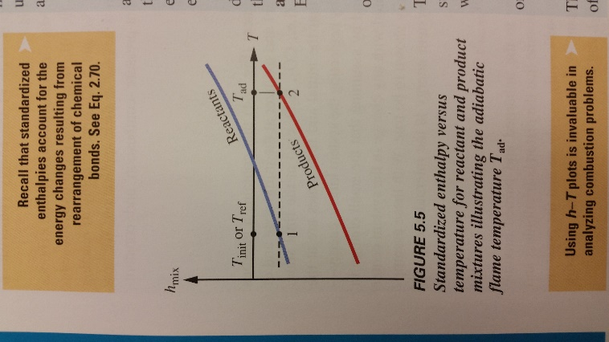Also we switch the h1 and h2 terms around so that we look at Qout instead of in:
  + If you know the initial and final mixture compositions and temperatures, you can use tabulated values to find h
  + Note that for a constant-pressure combustion AND adiabatic process, there is a maximum temperature that can be reached: Tad
    - “**Constant-pressure adiabatic flame temperature**”
    - **For such a process, the initial enthalpy equals the final enthalpy!**
* Constant-Volume Combustion:
  + We start again with:
  + But since the change in volume is 0, the work term drops out
  + We also rewrite it as Qout, not Qin
  + To evaluate the **constant volume adiabatic flame temperature** you set Qout = 0
  + Then you know that U is a function of T and P so for both sides U(T, P) but for the initial and final states
  + You get the exact same curve as in Figure 5.5 but instead of h, it’s u
  + Also, since most tables only have h instead of u, we rearrange the equation:
  + Then you can substitute NRT for the PVs
  + You can also do some substitution with N=M/Mm to get:
  + Mm is the molar mass

Skipped the two sample problems, might be worth going over them

5.3 – Energy Conservation for Control Volumes:

* We start by developing steady-state expressions of energy conservation for integral control volumes, followed by the unsteady case
* **For steady-state and steady flow, properties do not change with time within the control volume or within the inlet and outlet streams.**
* We assume that fluid properties are uniform where the flow crosses the control surface
* 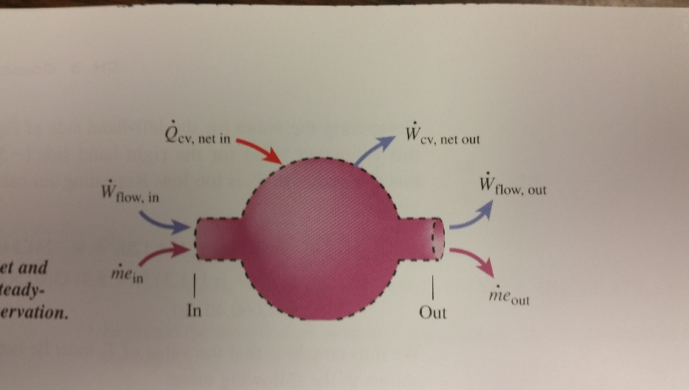We begin by identifying all the energy interactions around the control surface:
  + The inlet stream carries energy inside the control volume (mein) and the exit stream carries energy out of the control volume (meou)
  + Flow work is performed by the surroundings to push the fluid into the control volume and the control volume performs work to push the fluid out.
  + **The control volume may also perform work that crosses the control surface at locations other than the fluid inlets and exit (Wcv, net out) FOR EXAMPLE: SHAFT WORK!**
  + Finally, there will be heat transfer into the control volume if there are temperatyre gradients.
* THOSE ARE ALL THE ENERGY INTERACTIONS THE CONTROL SURFACE CAN HAVE.
* So we apply this conservation of energy principle:
  + **“In steady state, the net rate at which energy crosses the control surface must be zero; that is, the rate at which energy enters the control volume must equal the rate at which energy exits.”:**
* If we take all the energies we just described into account, that gives:
* Rearranging:
* e is the specific energy (energy per unit mass) and it equal to the internal, kinetic and potential energies of the fluid
  + So you can rewrite it as e = u + (ke) + (pe)
* Also the flow work is equal to ṁPv
  + V is specific volume
  + So when you substitute that and factor m out, you can combine u and PV into h
* So you can substitute all those things in and then factor out the ṁ:
* Which can more concisely be written as:

**Chapter 6: Second Law of Thermodynamics and Some of its Consequences**

6.1 - Historical Context:

* Sadi Carnot worked to understand the relationship between heat supplied to an engine and the work it produced
* Reversible cycles are the most efficient cycles of all.
* The efficiency of the conversion of heat to work depends only on the temperatures at which an engine receives and rejects heat
* Rudolf Clausius defined the term entropy and is credited with the discoverer of the second law.

6.2 - Usefulness of the Second Law:

* It establishes theoretical limits of performance of cycles, engines and other energy conversion devices. It also provides means to quantitatively compare real devices with these theoretical ideals.
* Determines the direction for any spontaneous change and determines the equilibrium state of any system.
* Other things too like a temperature scale independent of the properties of any substance.

6.3 – One Fundamental Statement of the Second Law:

* Statements of the first law:
  + Though all work can be converted completely to heat, heat cannot be completely and continuously converted into work.
  + **Kelvin-Planck Statement:** It is impossible to construct a cyclically operating device for which the sole effect is exchange of heat with a single reservoir and the creation of an equivalent amount of work.
* So not all forms of energy are equally valuable

Skipped some stuff

6.3a – Reservoirs

* A heat reservoir is a source of heat energy sufficiently large that extracting any desired amount of energy won’t change it’s temperature.
  + E.g. earth’s atmosphere, oceans, lakes and rivers
  + You can take energy from those without changing their temperature (an AC does that)

6.3b – Heat Engines

* A heat engine is the cyclically operating device in the Kelvin-Planck statement.

**There’s a good picture to add here**

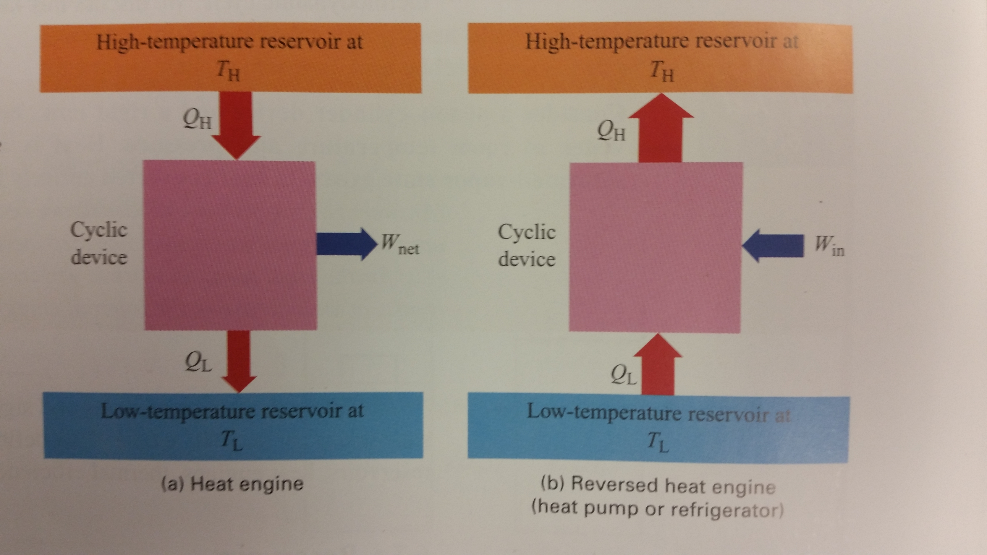

* The engine takes high energy, converts some to work and rejects the rest to a low-temperature reservoir.
  + The working fluid then returns to its original state with work input
* The first law relates the heat supplied and rejected during the cycle to the net work produced:
* The internal energy change is 0 because the initial and final states are identical.
* **Heat and work are path functions**
* QH is the energy in and out of the high-temperature reservoir, QL is the energy in and out of the low-temperature reservoir
* In the example of the Rankine-cycle steam power plant, you don’t include the work in the water pump
* A heat pump removes energy from the atmosphere, ground or body of water and delivers energy to provide residential heating. The desired effect is to supply energy to the high-temperature reservoir.
  + The desired effect for a refrigerator is the removal of energy from the low – temperature reservoir.

Skipped some more stuff (a bit)

6.3c – Thermal Efficiency

* Thermal efficiency (first law efficiency) for heat engines is the ratio of net useful work produced to the heat energy supplied
* For the efficiency of a heat pump, it’s the output heat over input energy.
* For the efficiency of a refrigerator, it’s the renergy removed from othe cold space over energy input.

6.3d – Reversibility

I skipped all of this except for:

* “A reversible process is one such that the system and all parts of the surroundings can be restored to their initial states”

6.4 – Consequences of the Kelvin-Planck Statement:

* Any and all heat engines must reject a portion of the heat energy suppled; thus, their thermal efficiency can never be 100%
  + You can’t continuously convert heat from a *single* reservoir to work
  + You need a second reservoir and the rejection of some heat
  + It is impossible to close the cycle without rejecting some heat.
* Efficiency of a reversible engine is solely determined by temperatures of hot and cold reservoir.

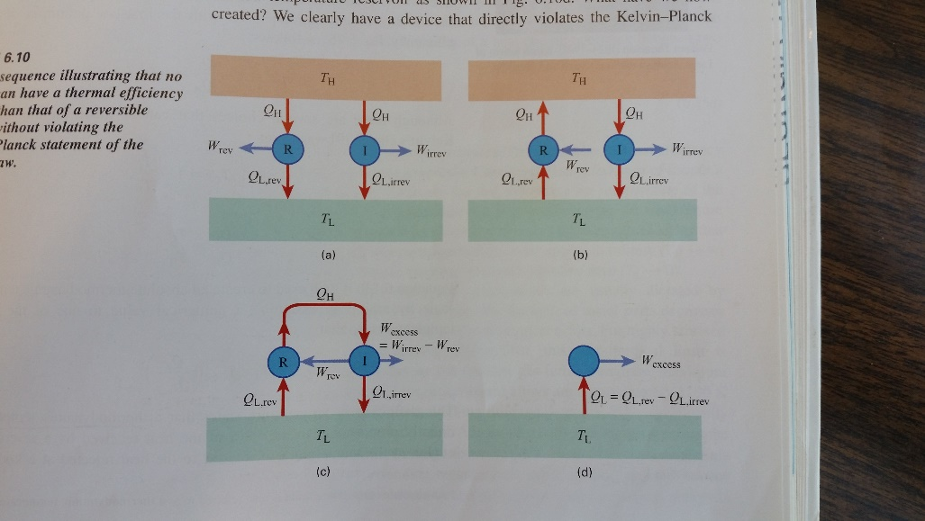

6.4b – The Carnot Efficiency:

* For a heat pump:
* For a refrigerator:

6.4c – Some reversible cycles:

* The Carnot cycle:
  + Reversible heat addition at constant temperature
  + Reversible adiabatic expansion
  + Reversible heat rejection at constant temperature
  + 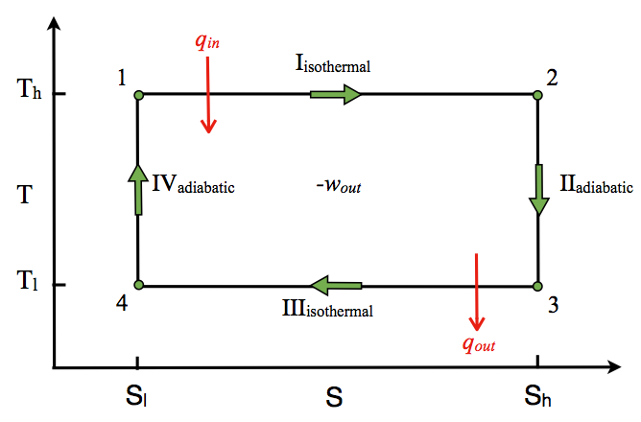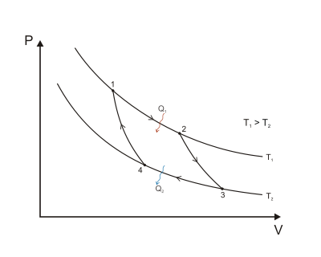Reversible adiabatic compression

6.6 – Entropy Revisited

6.6e – Isentropic Efficiency:

* We use entropy to quantify performance of practical devies